บ ๕.๓/ผ ๑-๐๑

ใบงานที่ ๐๑
สภาพแวดล้อมทางธรรมชาติ

ให้นักเรียนแต่ละกลุ่มสืบค้นข้อมูลเกี่ยวกับสภาพแวดล้อมทางธรรมชาติในจังหวัดที่ตนเองอาศัยอยู่
แล้วบันทึกข้อมูล

๑. จังหวัดที่ฉันอาศัยอยู่มีสภาพแวดล้อมทางธรรมชาติ ดังนี้
.......................................................................................................................................................
.......................................................................................................................................................
๒. จากสภาพแวดล้อมดังกล่าว ทำให้ผู้คนในจังหวัดของฉันมีลักษณะการดำรงชีวิต ดังนี้
.......................................................................................................................................................
.......................................................................................................................................................
๓. ลักษณะทรัพยากรธรรมชาติในจังหวัดของฉัน เป็นดังนี้
๑) ดิน..............................................................................................................................................
.......................................................................................................................................................
๒) น้ำ...............................................................................................................................................
.......................................................................................................................................................
๓) ป่าไม้...........................................................................................................................................
........................................................................................................................................................
๔) แร่ธาตุ..........................................................................................................................................
.......................................................................................................................................................
๕) สัตว์ป่า.........................................................................................................................................
……………………………………………………………………………………………………………………………………….

สมาชิกกลุ่ม

๑. ชื่อ..............................................สกุล..............................................ชั้น..............เลขที่..............
๒. ชื่อ..............................................สกุล..............................................ชั้น..............เลขที่..............
๓. ชื่อ..............................................สกุล..............................................ชั้น..............เลขที่..............
๔. ชื่อ..............................................สกุล................................................ชั้น............เลขที่............
บ ๕.๑/ผ ๑-๐๒

ใบงานที่ ๐๒
ปัจจัยที่ทำให้สภาพแวดล้อมเปลี่ยนแปลง

คำชี้แจงให้นักเรียนนำตัวเลือกที่กำหนดให้เติมใต้ภาพให้สอดคล้อง
ปัจจัยจากธรรมชาติ ปัจจัยจากมนุษย์

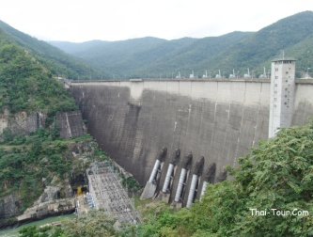
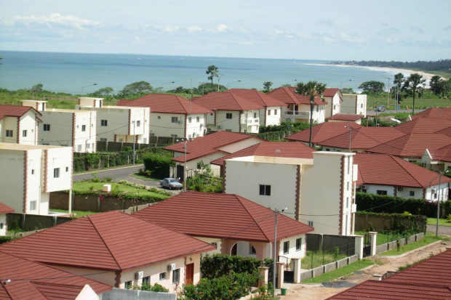
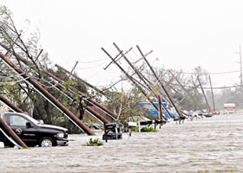

........................................... ............................................. .............................................
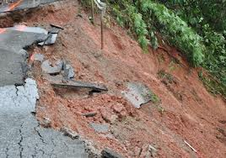
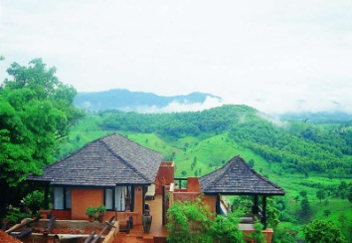
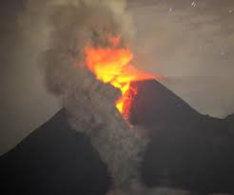

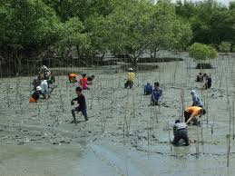
............................................. ............................................. .............................................
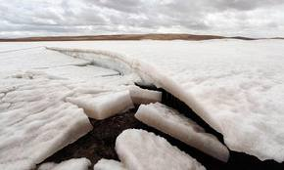
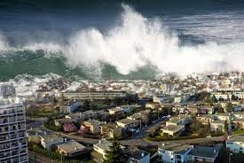

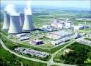
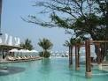
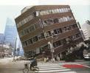
............................................. ............................................. .............................................

............................................. ............................................. .............................................
๑. ชื่อ........................................... สกุล.................................................ชั้น..............เลขที่………….
๒. ชื่อ.......................................... สกุล..................................................ชั้น..............เลขที่………….

