**หน่วยที่ 6 Festivals & Celebrations เรื่อง Great Days เรื่องย่อยที่ 4 The King’s Great Day**

ต.6/ผ.4

★★★★

**ใบงานที่ 2 King Bhumibol**

**Instructions:** Read the text and answer the questions.

อ่านเนื้อเรื่องแล้วตอบคำถาม

**King Bhumibol**

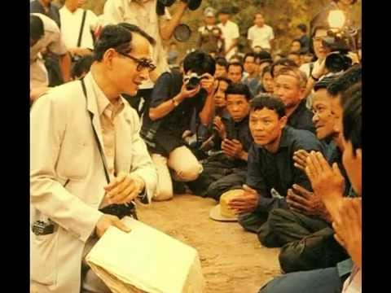

King Bhumibol Adulyadej was born on Monday,

5th December 1927. He was the youngest son of Prince Mahidol

of Songkhla and Mom Sangwal. He married Queen Sirikit on

28th April 1950. He went to every place in Thailand to visit his

people. He saw the farmers’ problems about the drought.

There was not enough rainfall for them to grow their crops.

So he made artificial rain for them.

ศัพท์: was born = พระราชสมภพ married = อภิเษกสมรส (แต่งงาน)

problem = ปัญหา drought = ความแห้งแล้ง

crops = พืชไร่ artificial rain = ฝนเทียม

**หน่วยที่ 6 Festivals & Celebrations เรื่อง Great Days เรื่องย่อยที่ 4 The King’s Great Day**

ต.6/ผ.4

★★★★

**ใบงานที่ 2 King Bhumibol (ต่อ)**

**Instructions:** Read the text and answer the questions.

อ่านเนื้อเรื่องแล้วตอบคำถาม



1. When was King Bhumibol born?

He was born on_________________________.

1. Who was King Bhumibol’s father?

__________________________was King Bhumibol’s

father.

1. Who is King’s Bhumibol’s wife?

___________________ is King Bhumibol’s wife.

1. Why did King Bhumibol go to every place

in Thailand?

Because he wanted to ______________________.

1. What can solve the drought?

___________________________________.